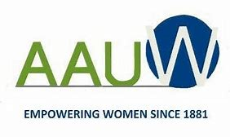

**WESTMINSTER- FOUNTAIN VALLEY- HUNTINGTON BEACH BRANCH**

**THE 32nd ANNUAL AUTHORS LUNCHEON**

**“PASSAGES: OUR JOURNEYS AND STORIES”**



**SATURDAY APRIL 26, 2025**

**MILE SQUARE GOLF COURSE**

**10401 WARNER AVENUE FOUNTAIN VALLEY**

**10:00AM – 2:00PM**

**FEATURING LOCAL AUTHORS :**

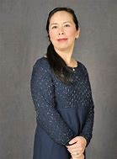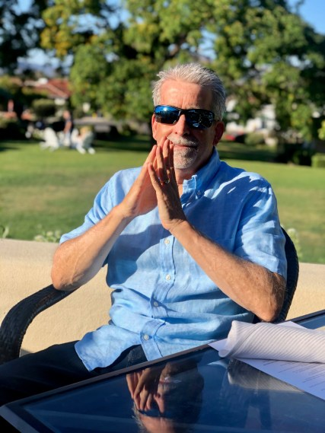

**Hong-My Basrai:**

**Behind the Red Curtain:**

**A memoir**

**John W. Thill:**

**A California Love Story**

**SILENT AUCTION BASKETS, DRAWINGS, BOOK SALES & SIGNINGS**

**RESERVATION FORMS AND INFORMATION AVAILABLE ONLINE**

**AT http://wfh-ca.aauw.net**